Student Worksheet

Under Pressure: Learning Activity Packet – Level I
An online lab that incorporates data collection, data analysis, graphing and differentiated instruction.

Name(s) : Section:

Level I – Minimum Difficulty
Date:

Discussion: With your lab partner, discuss how you would define pressure. Record your definition of pressure in the space below.

Lab Instructions:
- Click on the following link or copy/paste it in your browser. http://phet.colorado.edu/en/simulations/category/html Select the simulation titled Under Pressure.
- From the toolbar, click the box titled “Metric Units”.
- Check to see if the fluid density reading is 1000 kg/m³. If not move the slider to make adjustments and then use the arrow keys to reach this measurement.

- Check to see if the “Gravity” tool is set to 9.8 m/s². The slider should be on “Earth”. If the slider is not in the correct position make adjustments as needed and use the arrow keys to reach this measurement.

- Once steps 1- 4 are completed, fill the tank with water. Water can be added by
pulling on the blue handle of the large faucet. Water may be removed by pulling on the handle of the
small faucet. The rate of water flow can be adjusted by how hard or easy you pull the handle.

Data Collection and Analysis:

- Once the tank is full, click on the pressure gauge and drag it to the bottom of the tank. Carefully position the gauge so that a reading appears on the screen of the pressure gauge. Record this reading:

kPa

- Leave the pressure gauge at the bottom of the tank and slowly pull the handle of the small faucet (releasing water from the tank). Observe the pressure gauge while water is being released from the tank. What did you notice? Record your observations below.

- Discuss what you observed with your lab partner and explain why you believe the pressure change you observed in step 7 occurred.

Refill the tank with water. Go to the toolbar and click “Grid”. You’ll notice that a depth measurement grid appears to the left of the tank. Leave the pressure gauge in place at the bottom of the tank. Add additional pressure gauges to each depth level by clicking and dragging them to each grid line. Place the final pressure gauge on top of the water level just above the surface which is located at 0 meters. When complete, your computer screen should look like the picture below:
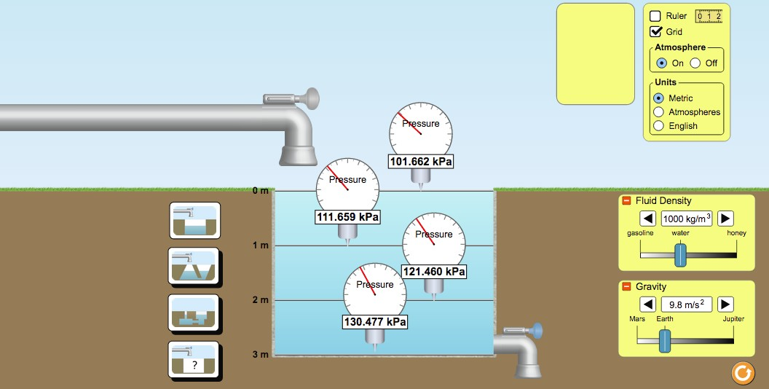

Read the pressure gauge at each depth and record the measurements of each gauge in Table 1. Your readings may be different from those seen in the picture (and that’s OK!)

Table 1: Under Pressure (Level I)

Water Depth (m) | Pressure (kPa)
0
1
2
3
Analysis Questions:
  - How did the depth of water effect pressure?

  - Was “pressure” recorded by the gauge placed at the water surface grid line located at 0 meters ? If so, what was the pressure gauge reading at this location?

  - Since the pressure gauge at 0 meters was not placed in the water and it showed a pressure measurement, where did the pressure come from?

  - Go to the toolbar and select “Atmosphere Off”. What changes did you observe in the pressure gauges? Did the presence of Earth’s atmosphere contribute to the pressure readings on all gauges (including those under water)?

Graphing: Under Pressure (Level 1)
Graph the data you collected in Table 1.
135

130
125
Pressure (kPa)
120
115
110
105
100

Analysis Questions:
0 1 2 3
Water Depth (m)

  - Describe the line plotted after connecting the coordinate points on the graph.

  - Does the shape of line show a direct variation or inverse variation?

Level 1 Summary: Pressure will increase as water depth increases. This type of relationship is known as a direct variation and can be represented on a graph by a straight line that slopes upward and to the right. Water pressure is also affected by the amount of air above the water. Like water, air can also put pressure on matter. The unit used to measure pressure in this lab was the kilopascal, kPa. Using your textbook or the internet, look up the definition of pressure. See how your definition on page 1 of this lab compares to the textbook/internet definition. Make adjustments if needed.

Student Worksheet

Under Pressure: Learning Activity Packet – Level II
An online lab that incorporates data collection, data analysis, graphing and differentiated instruction.

Name(s) : Section:

Level II – Intermediate Difficulty
Date:

Discussion: With your lab partner, use a textbook or computer to find the formula used to calculate pressure. Write that formula in the space below.

Lab Instructions:

- Click on the following link or copy/paste it in your browser. http://phet.colorado.edu/en/simulations/category/html Select the simulation titled Under Pressure. From the toolbar, click the third style of water tank. See the picture below for reference.
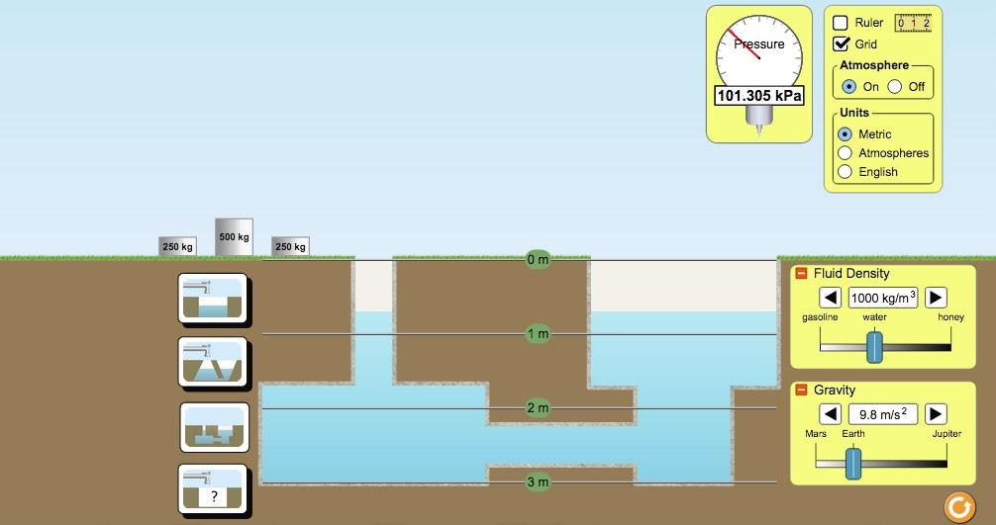
Select this icon

- From the “Units” section of the toolbar, choose atmospheres as the unit used to describe pressure.

- Select water from the “Fluid Density” menu option and Earth from the “Gravity” menu option.

- Place pressure gauges at the 3m, 2m, and 1m depth marks as shown in the picture below.
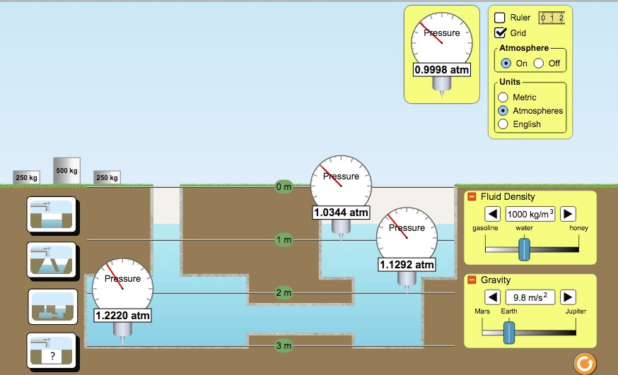

Record the initial pressure of each gauge in the appropriate row /column in Table 1.

Table 1: Under Pressure (Level II)

Water Depth (m) | Initial Pressure no additional mass added | Pressure after the addition of 250 kg | Pressure after the addition of 500 kg | Pressure after the addition of 750 kg | Pressure after the addition of  1000 kg
3 | atm | atm | atm | atm | atm
2 | atm | atm | atm | atm | atm
1 | atm | atm | atm | atm | atm

Analysis Questions:

- In general, how did the water pressure in the tank change when mass was added to the fluid?

- Did a change in pressure occur at each depth when mass was added to the water tank?

Using Data from Table 1, complete Table 2. Table 2: Under Pressure (Level II)

Water Depth (m) | Initial Pressure (atm) | Pressure after the addition  of 250 kg | Change in Pressure  ( column 3 – column 2 )
3 | atm | atm | atm
2 | atm | atm | atm
1 | atm | atm | atm

Water Depth (m) | Initial Pressure (atm) | Pressure after the addition  of 500 kg | Change in Pressure  ( column 3 – column 2 )
3 | atm | atm | atm
2 | atm | atm | atm
1 | atm | atm | atm

Water Depth (m) | Initial Pressure (atm) | Pressure after the addition  of 750 kg | Change in Pressure  ( column 3 – column 2 )
3 | atm | atm | atm
2 | atm | atm | atm
1 | atm | atm | atm

Water Depth (m) | Initial Pressure (atm) | Pressure after the addition  of 1000 kg | Change in Pressure  ( column 3 – column 2 )
3 | atm | atm | atm
2 | atm | atm | atm
1 | atm | atm | atm

Note: An increase in mass will ultimately result in an increase in weight for objects on Earth. The weight of an object can be calculated using the formula: Weight = mass x gravity.

Remember, W = m x g . The unit used to describe weight is the Newton, N.

1N = 1kgm/s²

Calculate the weight of each mass using 9.8 m/s² as the value of “g”. Record your data in Table 3.

Table 3 : Under Pressure (Level II)

mass (kg) | Value of “g” (m/s²) | Weight (N)  (mass x gravity)
250 | 9.8
500 | 9.8
750 | 9.8
1000 | 9.8

Analysis Questions:

- What happens to weight as mass increases? If mass is doubled, does weight also double (While on Earth)? If mass is tripled does weight also triple (while on Earth)? Explain how you derived your answer.

- On Earth, is the relationship between mass and weight a direct variation or inverse variation? Explain why or why not?

- Review Table 2. Examine the relationship that exists between mass and pressure. Do you consider this to be a direct variation or inverse variation? Explain why or why not.

- When mass was increased by a factor of three (i.e. tripled), did the pressure exerted within the tank also triple at all depth levels?

- Review Table 2. When pressure within the tank changed due to the addition of mass, did each grid-level depth experience the same amount of pressure change?

Summary:
Based on your observations and data, work with your lab partner to write a summary describing how the pressure of a fluid is affected by the addition of mass (or weight). In your summary discuss how pressure is affected at various depth levels. For further research use your textbook or computer to read about Pascal’s Principle.

